“Greecy” Unit significant Olympian Gods and Goddesses

Aphrodite

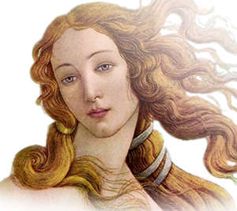

Aphrodite was the goddess of love, desire and beauty. Apart from her natural beauty, she also had a magical girdle that compelled everyone to desire her.
There are two accounts of her birth. According to one, she was the daughter of Zeus and Dione, the mother goddess worshipped at the Oracls of Dodona.
Aphrodite was married to Hephaestus; however, she had an affair with Ares, god of war. When Hephaestus found out about the affair, he devised a plan and managed to humiliate his wife and her lover to the other Olympians. Her holy tree was the myrtle, while her holy birds were the dove, the swan, and the sparrow.
Aphrodite represented sex, affection, and the attraction that binds people together.

Aphrodite Is also called Venus, Afrodite.

Athena

Athena was the Greek virgin goddess of reason, intelligent activity, arts and literature. She was the daughter of Zeus; her birth is unique in that she did not have a mother. Instead, she sprang full grown and clad in armour from Zeus' forehead.
She was fierce and brave in battle; however, she only took part in wars that defended the state and home from outside enemies. She was the patron of the city, handcraft, and agriculture. She invented the bridle, which permitted man to tame horses, the trumpet, the flute, the pot, the rake, the plow, the yoke, the ship, and the chariot. She was the embodiment of wisdom, reason, and purity. She was Zeus' favourite child and was allowed to use his weapons including his thunderbolt. Her holy tree was the olive tree and she was often symbolised as an owl.
She became the patron goddess of Athens after winning a contest against Poseidon by offering the olive tree to the Athenians. It is evident that Athena and Athens derive from the same root; Athens (or Athenae) is in plural form, because it represents the sisterhood of the goddess that existed there. Similarly, Athena was called Mykene in the city of Mycenae (also a plural after the respective sisterhood), and Thebe in the city of Thebes (or Thebae, both plural forms).
See Also: Birth of Athena, Zeus, Poseidon, Theogony
Athena Is also called Minerva, Athina, Athene.

Zeus
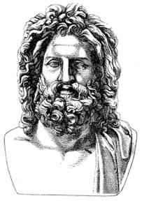

Zeus was the god of the sky and ruler of the Olympian gods. He overthrew his father, Cronus, and then drew lots with his brothers Poseidon and Hades, in order to decide who would succeed their father on the throne. Zeus won the draw and became the supreme ruler of the gods, as well as lord of the sky and rain. His weapon was a thunderbolt which he hurled at those who displeased or defied him, especially liars and oathbreakers. He was married toHera but often tested her patience, as he was infamous for his many affairs.
Zeus, the presiding deity of the universe, ruler of the skies and the earth, was regarded by the Greeks as the god of all natural phenomena on the sky; the personification of the laws of nature; the ruler of the state; and finally, the father of gods and men.
Using his shield, the Aegis, Zeus could create all natural phenomena related to the air and the sky, such as storms, tempests, and intense darkness. At his command, mighty thunders would flash and lightnings would roll, wreaking havoc; or the skies would open to rejuvenate the earth with life-giving water.
As the personification of the operations of nature, he represented the grand laws of unchanging and harmonious order, by which both the natural and the spiritual world were governed. He was the god of regulated time as marked by the changing seasons and the regular succession of day and night, in contrast to what his father Cronus represented before him; absolute time, i.e. eternity.
As the ruler of the state, he was the source of kingly power, the upholder of all institutions connected to the state, and the friend and patron of princes, whom he guarded and assisted with his advice and counsel. He was also the protector of the people, and watched over the welfare of the whole community.
As the father of the gods, Zeus ascertained that each deity perform their individual duty, punished their misdeeds, settled their disputes, and acted towards them on all occasions as their all-knowing counsellor and mighty friend.
As the father of men, he took a paternal interest in the actions and well-being of mortals. He watched over them with tender solicitude, rewarding truth, charity, and fairness, while severely punishing perjury and cruelty. Even the poorest and most forlorn wanderer could find a powerful advocate in Zeus, for he, as a wise and merciful paternal figure, demanded that the wealthy inhabitants of the earth be attentive to the needs of their less fortunate fellow citizens.
Zeus Is also called Jupiter, Dias.

Hades

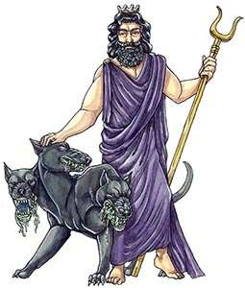

Hades was the brother of Zeus and Poseidon. After the overthrow of their father, Cronus, he drew lots with them to share the universe. He drew poorly, which resulted in becoming lord of the underworld and ruler of the dead. Nevertheless, he was not considered to be death itself, as this was a different god, called Thanatos. Greedy like his brother Poseidon, he was mainly interested in increasing his subjects, and anyone whose deeds resulted in people dying was favoured by him. The Erinnyes (the Furies) were welcomed guests in his kingdom.
The Greeks were not keen on uttering his name, afraid of causing some kind of reaction that would end up with them dead sooner. Instead, they decided to give him another name, Plouton, deriving from the Greek word for wealth, due to the precious metals mined from the earth. Thus, Hades also became the god of wealth.
Although an Olympian, Hades preferred the Underworld and rarely left his kingdom. His weapon was a pitchfork, which he used to create earthquakes, similar to the way Poseidon used his trident. He also had a helmet of invisibility, which he had received as a gift from the Cyclopes, in order to use it during the clash of the Titans. He was married to Persephone, daughter of Demeter, whom Hades abducted and carried down to the Underworld. Hades Is also called Pluto, Dis Pater, Orcus, Plouton.

Poseidon

Poseidon is the god of the sea and protector of all aquatic features. Brother of Zeus and Hades, after the overthrow of their father, Cronus, he drew lots with them to share the universe. He ended up becoming lord of the sea. He was widely worshipped by seamen. He married Amphitrite, one of the granddaughters of the Titan Oceanus.
At one point he desired Demeter. To deter him, Demeter asked him to make the most beautiful animal that the world had ever seen. So, in an effort to impress her, Poseidon created the first horse. In some accounts, his first attempts were unsuccessful and created a variety of other animals in his quest; thus, by the time the horse was created, his passion for Demeter had diminished.
His weapon was a trident, with which he could make the earth shake, causing earthquakes, and shatter any object. He was second to Zeus in power amongst the gods. He was considered by Greeks to have a difficult quarrelsome personality. Combined with his greed, he had a series of disputes with other gods during his various attempts to take over the cities they were patrons of.
See Also: Theseus, Pegasus, Oceanus, Theogony, Zeus, Demeter
Poseidon Is also called Neptune.

